What are the 5 Levels of Leadership?

By [John C Maxwell](http://johnmaxwellonleadership.com/author/admin/)

In less than two months, my new book, The 5 Levels of Leadership, comes out! Last week I shared an excerpt that explained why I wrote the book. Today, I’d love to give you a quick overview and description of Level 1.

In the book, each level is explained in its own section, where you’ll learn the upside of the level, the downside, the best behaviors for that level, the beliefs that help a leader move up to the next level, and how the level relates to the Laws of Leadership.

[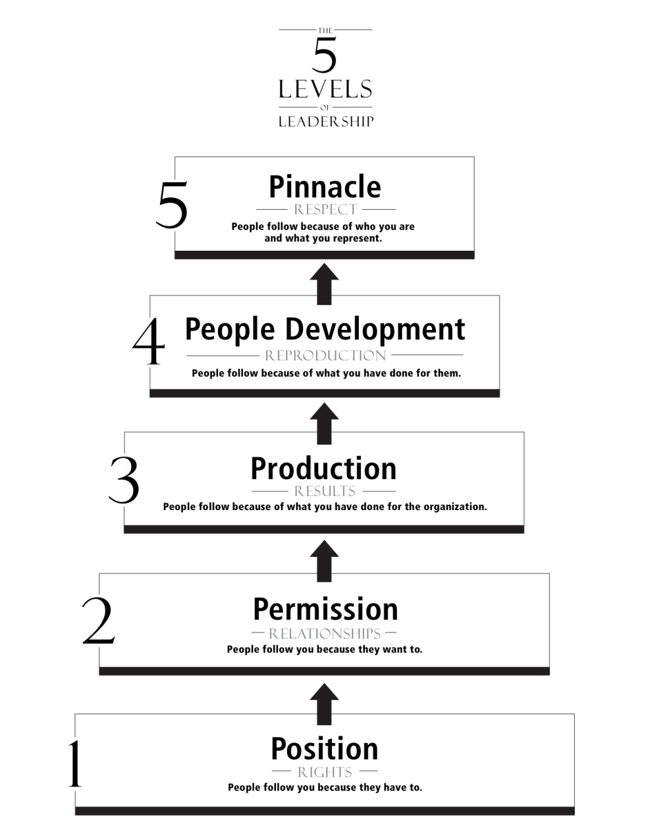](http://johnmaxwellonleadership.com/wp-content/uploads/2011/08/5-Levels-Final.jpg)

Let’s talk briefly about Level 1: Position. This is the lowest level of leadership—the entry level. The only influence a positional leader has is that which comes with the job title. People follow because they have to. Positional leadership is based on the rights granted by the position and title. Nothing is wrong with having a leadership position. Everything is wrong with using position to get people to follow. Position is a poor substitute for influence.

People who make it only to Level 1 may be bosses, but they are never leaders. They have subordinates, not team members. They rely on rules, regulations, policies, and organization charts to control their people. Their people will only follow them within the stated boundaries of their authority. And their people will usually do only what is required of them. When positional leaders ask for extra effort or time, they rarely get it.

Positional leaders usually have difficulty working with volunteers, younger people, and the highly educated. Why? Because positional leaders have no influence, and these types of people tend to be more independent.

Position is the only level that does not require ability and effort to achieve. Anyone can be appointed to a position. This means that position is a fine starting point, but every leader should aspire to grow beyond Level 1.